Rivers Run Wild: The Columbia and the Coast Range

**10th Annual Bretz Club Schedule, May 2-4, 2019**

**Thursday, May 2, 2019:**

Organizers and Most Participants arrive 5pm-10pm. Check in, Meet & Greet at the Lodge.

**ToDo: Check-in**

**Raffle Table**

**Drinks & Snacks**

**Room set-up**

**Thurs Night Clean-up**

**Friday, May 3, 2019: Scientific Program, Camp Kiwanilong, Warrenton, Oregon**

*All talks, popups and posters are in the Nature Barn; meals and evening gatherings the in the Lodge.*

7:30am Breakfast / Check-in for Friday Arrivals (*Lodge*)

8:30am Introductions and orientation to Bretz Club & Camp Kiwanilong (*Nature Barn*)

9am Key note #1: **Lydia Staisch** (USGS, Menlo Park)

The ancestral rivers of the Pacific Northwest: where they were and why they changed

**10:30am Meet with Raffle, Posters, Pop-ups students**

10:30am Coffee Break (*Hot beverages available, bring your own travel mugs!*)

**11am Announcements: Sales & Science Students (Raffle, Water Bottle, Posters, Pop-ups).**

11am Key note #2: **Allison Pfeiffer** (Western Washington University)

Sediment supply controls on a century of river bed (in)stability in the Pacific Northwest

12:30pm Lunch

2pm Pop-ups (3-minutes each) on whatever comes to mind (*those who preregister have priority*)

**3:45pm Meet with Clean-Up, Check-Out Students**

3:45pm Coffee break

4pm Poster Session

6pm Dinner

7:00pm Key note #3: **Amy East** (USGS, Santa Cruz)

How are landscapes in the western U.S. responding to modern climate change?

8:30 pm Evening Extravaganza: Raffle, music and merriment (*Lodge*)

**Saturday, May 4, 2019:**  **A Big River Runs Through It—The Columbia and the Coast Range**

Jim O’Connor, Charlie Cannon, Ray Wells

7:30am Breakfast & **make your own bag lunch**

8:30am Pack up your cabin, assemble at the Lodge; **Everyone will be pitch in to leave the Camp cleaner than we found it – Amy K. will lead this.**

9:30am Field trip departs Camp Kiwanilong *(for details see field guide)* 2019 Field Trip Guide. We may leave vehicles at the Camp if desired.

**10:00 – 11:30 am Stop 1**

Stop 1: Astoria Column

**11:30 am – 1:00 pm Stop 2**

Stop 2: “Bay head delta” and tidal marsh dynamics

(No bathrooms here)

**1:30 – 3:00 pm Stop 3**

Stop 3: Bradley State Scenic Viewpoint



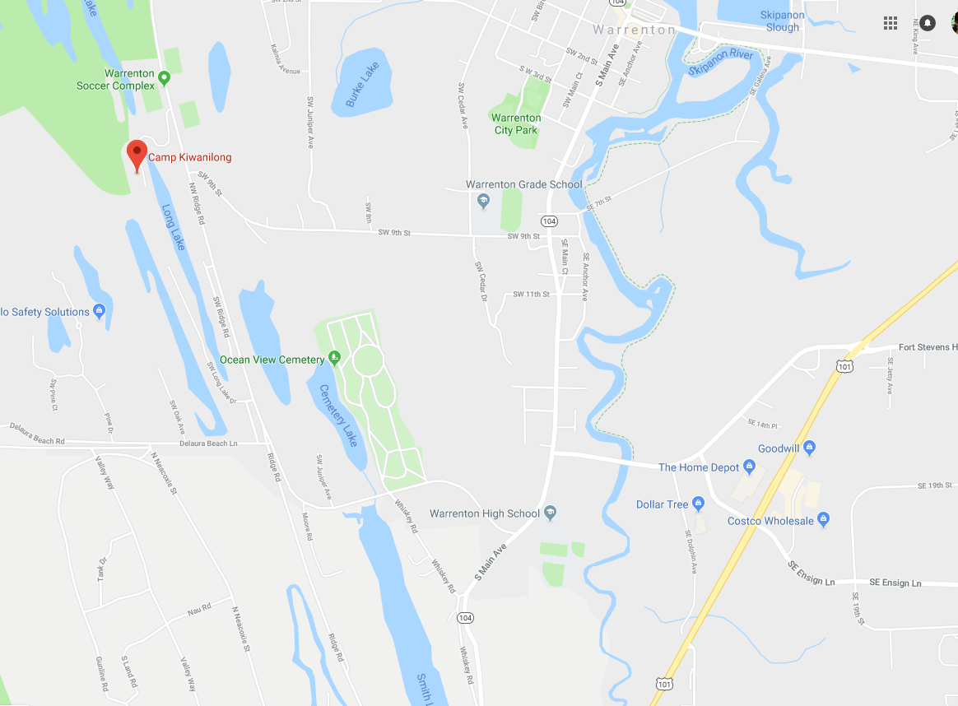

Driving Directions:

* From US-101, take OR-104 to Ridge Rd.
* Turn west into the Warrenton Soccer Complex.
* Proceed through the gate on the left to Camp Kiwanilong

<https://goo.gl/maps/LpbojgEvNUs>

Camp Kiwanilong Buildings & Trail Map

Description generated with high confidence

North-ish